International Imam Hussain Council; Syeda Fatima Interfaith Conference 8 June 2015: Recognizing women as key players in our society today

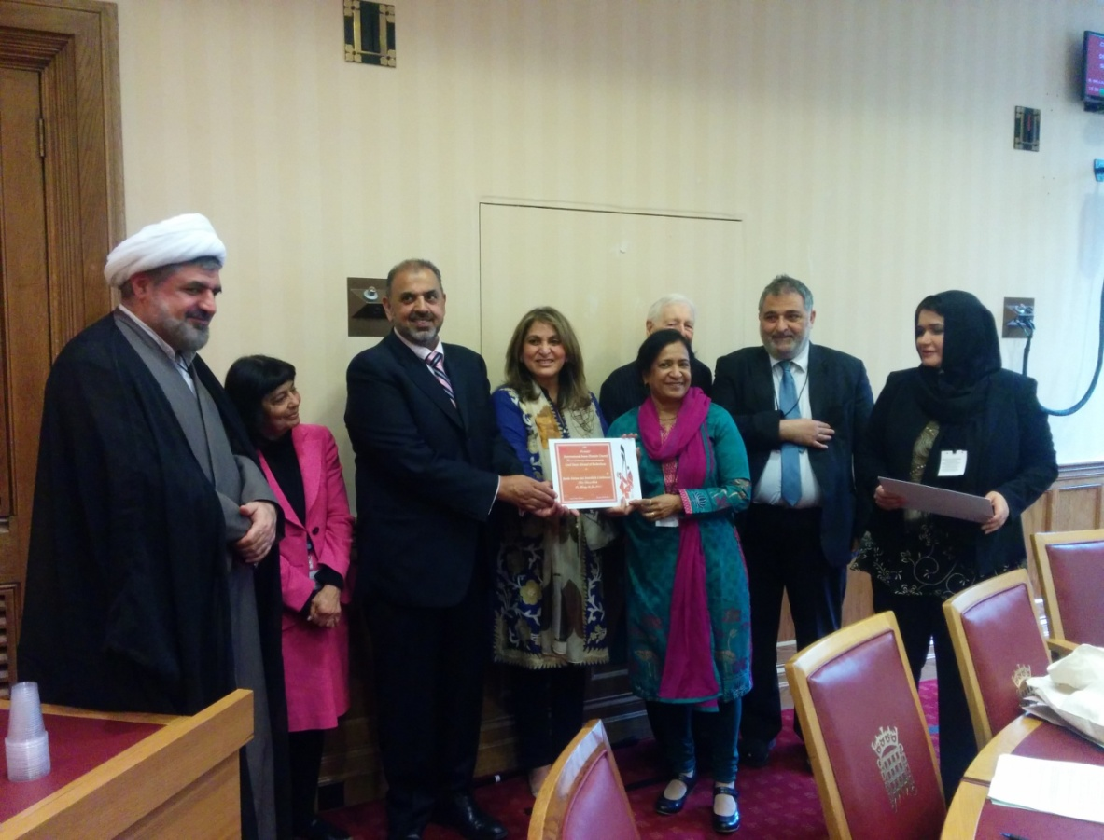
Dr. Lakshmi Vyas is felicitated with an award at the Syeda Fatima Conference held at House of Lords on 8/6/15. With Lord Avebury, Baroness Ashraf, Lord Ahmad, Yousef Al_khoei, Barrister Rubab Rizvi and others.

Presentation Excerpt
Medha Patkar addressing a mammoth crowd of local population
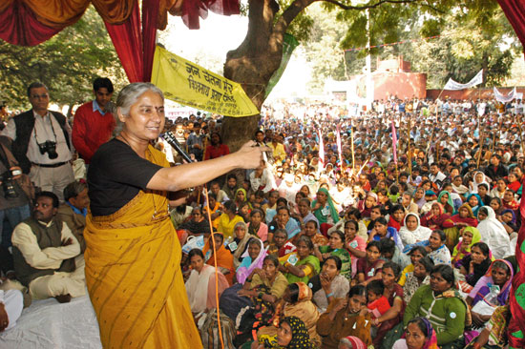
MEDHA PATKAR: Known and loved by millions of villagers and city-folk of India and the world over, Medha Patkar, founder of the Narmada Bachao Andolan and the National Alliance of People's Movements

Medha’s Awards: Deena Nath Mangeshkar Award, Mahatma Phule Award, Right Livelihood Award, Goldman Environment Prize, Green Ribbon Award for Best International Political Campaigner by BBC, and the Human Rights Defender's Award from Amnesty International.
Medha has triumphed in getting justice to people and she continues to pursue her work selflessly
Women, since ancient, medieval and modern times are gifted with outstanding qualities of love, affection, peace, patience, perseverance, maintain and uphold relationship, empowerment, and above all the sense of ‘feeling’ which takes them above all living beings. These show resemblances to mythological women like fearless Durga, Goddess of wealth Lakshmi, the bold and mighty Jhansi ki Rani, the obedient and sacred Mirabhai, and many others to the modern women from India who are holding some of the highest positions in all walks of life locally and globally. Women truly deserve to be called as backbone of progress and prosperity.
I wish to salute all women to have endured and adapted to changing global scenario.
Dr. Lakshmi Vyas, Vice President Hindu Forum of Europe.

